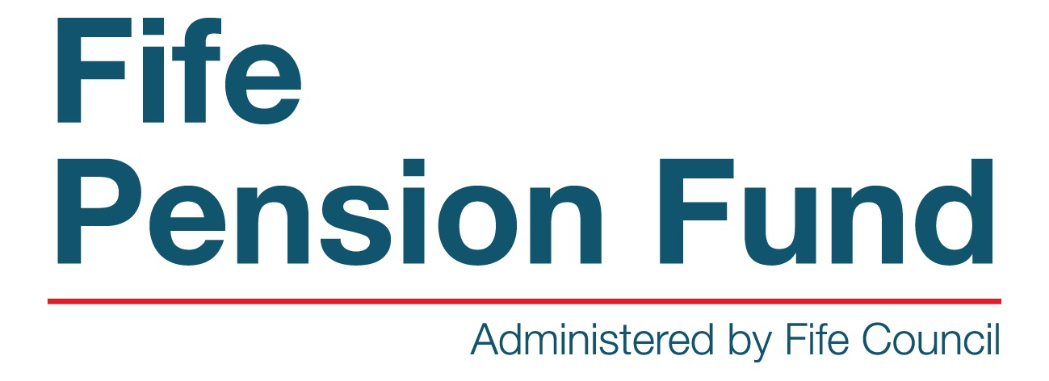
THE LOCAL GOVERNMENT PENSION SCHEME

NOTICE OF RETIREMENT

This form is only to be used by employers who do not have access to First Contact.

All Fife Council employees/managers are required to use the Retirement Offering on First Contact (http://assyst.fife:8080/assystnet/).

Employee Details
First Name: |  |  | Surname:
National Insurance Number: |  |  | Employment No:
Address:

Post Code:

Retiral Date:

Reason for Retiral (Please tick relevant box)
Voluntary age 55 onwards |  | Ill-health
Redundancy |  | Interest of Efficiency
Flexible Retirement (from age 55)

Employer Declaration
Authorised  Signatory: |  | Date:
Print Name: |  | Telephone No:
E-Mail: |  | Employer:

Guidance Notes
- This form must be sent to the Pension Section at least 8 weeks before the employee’s retiral.
- If retirement is due to ill health or under the employer’s early retiral scheme please ensure the relevant certificate/authorisation is forwarded to the Pensions Section.
- The date of retiral is the date the employee ceases employment.
- The Termination Notification must be completed in addition to this advance notification, however, it should not delay the issue of this form.

